**Tutorial 05. GitHub collaboration**

V1.0

28/02/2021

You are going to learn how to do team collaboration with GitHub. Below are the topics of this tutorial.

**Topics**

**1.** **Build a team for a repository** 1

**Step 1.** **qiaoli116 add qiaoli116-2 as collaborator** 1

**Step 2.** **qiaoli116-2 check email for invitation** 2

**Step 3.** **qiaoli116-2 accept invitation** 2

**Step 4.** **qiaoli116-2 is now a collaborator** 3

**Class activity** 3

**2.** **Coding collaboration – work on main branch** 4

**Step 1.** **All members join the repository** 4

**Step 2.** **All members clone the repository** 4

**Step 3.** **Repository owner creates team.html** 4

**Step 4.** **All collaborators refresh local repository** 4

**Step 5.** **One collaborator update team.html** 4

**Step 6.** **Everyone refreshes local repository** 5

**Step 7.** **Repeat step 5 and step 6** 5

**Step 8.** **Review results** 5

**Team collaboration challenge 1** 5

**Discussion** 5

**3.** **Code collaboration – restricted access to main branch** 5

**Challenge** 6

1. **Build a team for a repository**

The following steps enable you to build a team for a repository. In the steps below, GitHub user **qiaoli116** is the owner of a repository “abc-website” and user **qiaoli116-2** will be invited as a collaborator.

* 1. **qiaoli116 add qiaoli116-2 as collaborator**

qiaoli116 follows this [guide](https://docs.github.com/en/account-and-profile/setting-up-and-managing-your-github-user-account/managing-access-to-your-personal-repositories/inviting-collaborators-to-a-personal-repository) to invite qiaoli116-2 as a collaborator as repository “**qiaoli116/abc-website**”

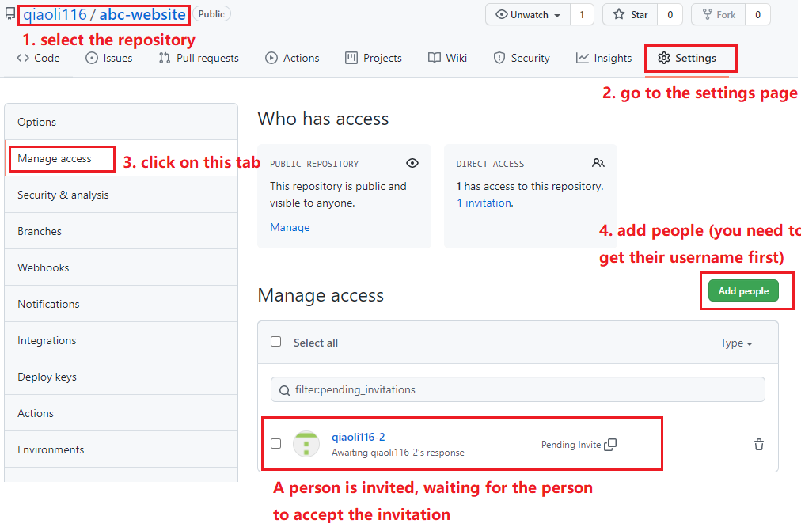

* 1. **qiaoli116-2 check email for invitation**

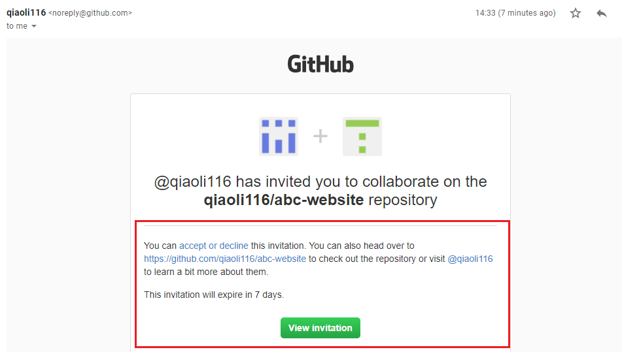

* 1. **qiaoli116-2 accept invitation**

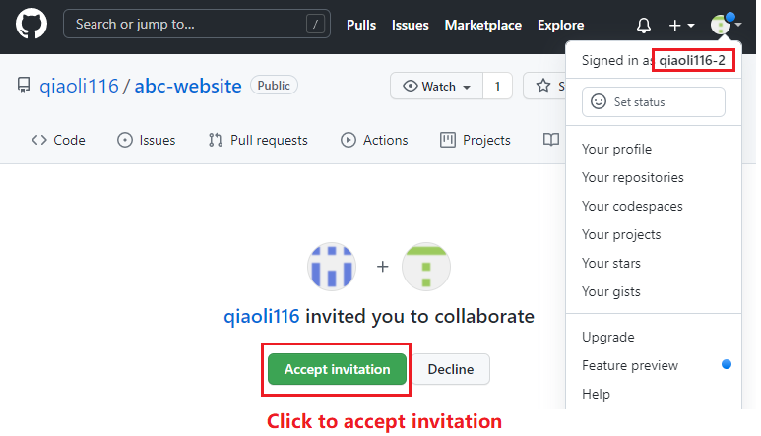

* 1. **qiaoli116-2 is now a collaborator**

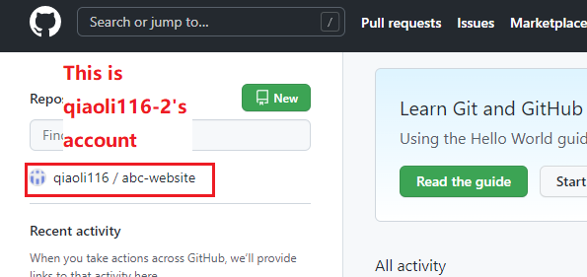

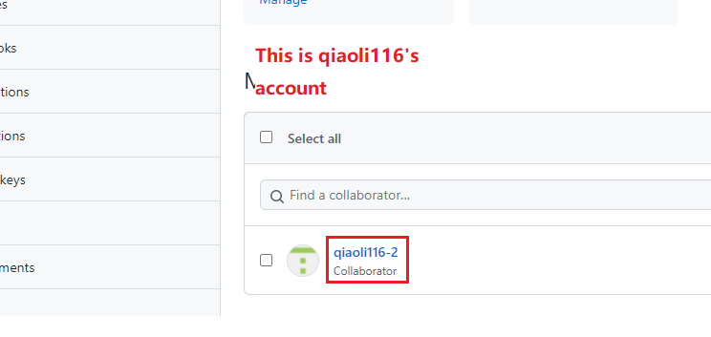

**Class activity**

* Create groups of 2~3 people in each group
* Exchange GitHub username with each other
* Create a repository for in your account
* Invite others as collaborators
* Confirm the collaborator status
* You should invite others as collaborators of your repository
* You should also be a collaborator of other’s repositories
* Record collaboration information as below

|  |  |  |  |
| --- | --- | --- | --- |
| **Repository Name** | **Repository URL** | **Owner and collaborators** | **Role (owner or collaborator)** |
| qiaoli116/abc-website | <https://github.com/qiaoli116/abc-website> | qiaoli116 | owner |
| qiaoli116-2 | collaborator |
| …… | …… |

1. **Coding collaboration – work on main branch**

Work with the team created in the activity above and do coding together. In this part, all team members will work on the **main** branch only. And all team members can push code to the main branch.

Follow the steps below and work on a repository that is owned by one of the members. Then repeat the process on other repositories owned by other members.

* 1. **All members join the repository**

Owner of the repository need to confirm that all other team members have joined your repository as collaborators.

Every collaborator confirms that the repository is visible in his/her shop.

* 1. **All members clone the repository**

Now everyone uses GitHub Desktop software to clone the repository to his/her local environment.

* 1. **Repository owner creates team.html**

Owner create a file called team.html with the following content. Change the text in red with your own name.

|  |
| --- |
| <h1>Our team</h1>  <ul>  <li>Owner's name</li>  </ul> |

Then publish to server.

* 1. **All collaborators refresh local repository**

Everyone else refresh the local repository by click on the “Fetch origin” button.

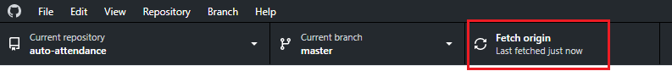

Everyone makes sure he/she can see the “team.html” file and the content

* 1. **One collaborator update team.html**

One of the collaborators update the team.html like below. Then publish to server

|  |
| --- |
| <h1>Our team</h1>  <ul>  <li>Owner's name</li>  <li>Your name</li>  </ul> |

* 1. **Everyone refreshes local repository**

All team members refer to step 4 above and refresh local repository. Make sure everyone can see the update in team.html.

* 1. **Repeat step 5 and step 6**

Repeat step 5 and step 6 above until everyone makes code contribution.

* 1. **Review results**

Everyone reviews the results.

**Team collaboration challenge 1**

Turn the **<li>John Doe</li>** to **<li><a href="./john.html">John Doe</a></li>** and create personal page for each member.

**Discussion**

What do you think about everyone being able to push codes to the main branch without restrictions?

1. **Code collaboration – restricted access to main branch**

It is chaotic if everyone can make direct submission to the main branch. Also, the submitted code should be reviewed by others and obtain approval before merge to the main branch. Adding access restrictions to the main branch is necessary. Configure the restriction as below

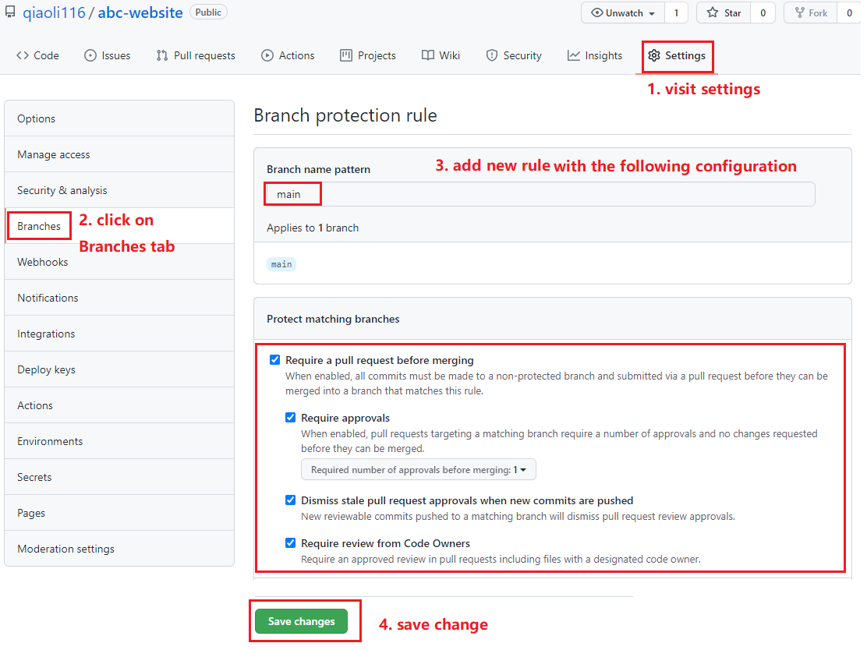

With the protection rule created above for the main branch. Everyone has to work on a subbranch for code submission. And then pull request to be created for code review and approval. After that, code can be merged to the main branch.

**Challenge**

Create protection rule as above and work again with your team.

End of this tutorial